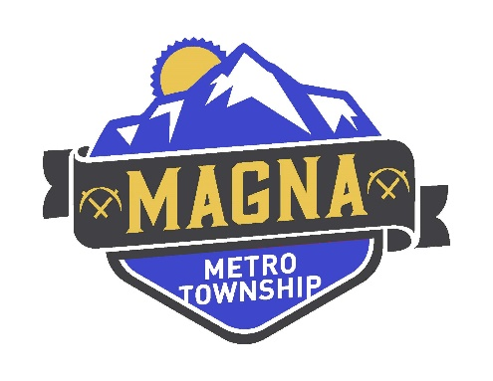
MAGNA METRO TOWNSHIP COUNCIL
MEETING SCHEDULE FOR 2023
Meeting Place: Webster Center (8952 W Magna Main St Magna, UT 84044)
Business and Workshop Meetings: 6:00PM
The Public is Welcome to Attend Both Meetings
Pursuant to State Law and Magna Ordinance, Councilmembers may participate electronically

(Unless Specified Otherwise)
Workshop Meetings Business Meetings
Tuesday January 10, 2023 Tuesday January 24, 2023
Tuesday February 14, 2023 Tuesday February 28, 2023
Tuesday March 14, 2023 Tuesday March 28, 2023
Tuesday April 11, 2023 Tuesday April 25, 2023
Tuesday May 9, 2023 Tuesday May 23, 2023
Tuesday June 13, 2023 Tuesday June 27, 2023
Tuesday July 11, 2023 Tuesday July 25, 2023
Tuesday August 8, 2023 Tuesday August 22, 2023
Tuesday September 12, 2023 Tuesday September 26, 2023
Tuesday October 10, 2023 Tuesday October 24, 2023
Tuesday November 14, 2023
Tuesday, November 21, 2023 – Special Meeting for Election
Tuesday December 12, 2023
Upon request with three working days’ notice, the Greater Salt Lake Municipal Services District will provide free auxiliary aids and services to qualified individuals (including sign language interpreters, alternative formats, etc.). For assistance, please call (385) 468-6707 – TTY 711. The
The public may attend. Meetings may be closed for reasons allowed by statute.

